Central African Republic

## Political Stability Estimate Data

The data set shows the political stability estimate of the country each year.

## # A tibble: 19 x 5  
## country iso3c date stability stabilityCategory4  
## <chr> <chr> <dbl> <dbl> <chr>   
## 1 Central African Republic CAF 1996 -1.21 highly unstable   
## 2 Central African Republic CAF 1998 -1.14 highly unstable   
## 3 Central African Republic CAF 2000 -1.12 highly unstable   
## 4 Central African Republic CAF 2002 -1.73 highly unstable   
## 5 Central African Republic CAF 2003 -1.54 highly unstable   
## 6 Central African Republic CAF 2004 -1.42 highly unstable   
## 7 Central African Republic CAF 2005 -1.43 highly unstable   
## 8 Central African Republic CAF 2006 -1.85 highly unstable   
## 9 Central African Republic CAF 2007 -1.85 highly unstable   
## 10 Central African Republic CAF 2008 -1.84 highly unstable   
## 11 Central African Republic CAF 2009 -1.91 highly unstable   
## 12 Central African Republic CAF 2010 -2.02 highly unstable   
## 13 Central African Republic CAF 2011 -1.79 highly unstable   
## 14 Central African Republic CAF 2012 -1.85 highly unstable   
## 15 Central African Republic CAF 2013 -2.15 highly unstable   
## 16 Central African Republic CAF 2014 -2.70 highly unstable   
## 17 Central African Republic CAF 2015 -1.90 highly unstable   
## 18 Central African Republic CAF 2016 -1.79 highly unstable   
## 19 Central African Republic CAF 2017 -1.94 highly unstable

## Political Stability Estimate Plot

The plot shows the trends of stabilization and destabilization for the each country.

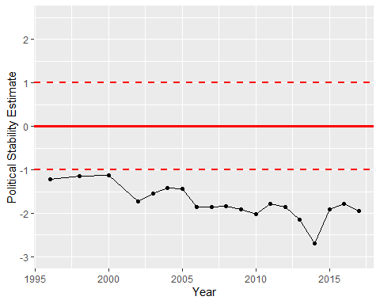

Political Stability Trend